Budgets
Key considerations for budget preparation

STEP 1: Cost the project first to determine expenses
- Timeframes – determine the length of project, critical work periods (this will help you estimate fees for participating artists and other personnel) and completion dates.
- Fees and living away from home allowances (per-diems) – make sure you are aware of arts industry awards when you are negotiating with artists and that you are budgeting appropriate rates.
− Performing Arts Awards
− Visual arts recommended fees
− Literature rates
- Travel – the more you can plan in advance the better rates you will get for air travel. For road travel, budget to reimburse participants for petrol and other related costs. Shop around for vehicle hire (truck/car). Travel is a competitive market and can be a source of in-kind support through discounts offered or a full sponsorship opportunity.
- Accommodation – check for competitive rates (you may be able to negotiate a discount and this can be recognised as an in-kind contribution).
- Insurance – you may need to arrange public liability insurance. Some peak bodies offer advice and discounted insurance cover through their membership benefits, e.g. Ausdance Queensland, Flying Arts Alliance, National Association for the Visual Arts (NAVA), Arts Law and Insurance in the Arts.
- Venue or rehearsal room hire – any discounts offered or contributions made will not only save you money, it will also provide evidence that your project is supported by others.
- Marketing – be sure you have a plan to maximise the outcomes of your project and that you have allocated sufficient funds to cover contracted personnel, online and printed marketing materials. Strategic use of digital marketing can be cost effective. Most projects have a limited number of public outcomes; you need to be sure you are reaching the widest possible audience.
- Administration, evaluation and reporting – (this is often overlooked or under-resourced in many project applications) – make sure someone in your team is responsible for managing all administrative aspects of the project:
− Financial: payments to artists, hire agreements, travel, insurances.
− Evaluation: ensure an evaluation plan is in place from project commencement (audience surveys and data capture, blogs, media).
− Reporting: understand the funding body’s outcome report requirements. Thorough and timely reporting at the conclusion of any project will enhance your reputation as a reliable applicant, worthy of further investment.

STEP 2: Now you know how much money you need to deliver the project, construct the income side of the budget
- Box office/participant fees – estimates should reflect the nature of the project, your target market (their capacity to pay), venue capacity and any risks such as weather impacting on outdoor events. It is best to estimate conservatively. Shortfalls will potentially put your project into deficit and may be viewed negatively by your funding body.
- Other funding – plan ahead. Be aware of funding programs available to you (and closing dates) from local, state and federal agencies. Confirmed funding from other programs will make your application more competitive.
- Sponsorship – again, plan ahead. It takes time to research and identify suitable sponsors or partners. Allocate appropriate time and resources to develop your proposal so that it aligns with the priorities of a potential partner. Even modest cash and/or in-kind contributions provide evidence that others see value in what you are doing, tells assessors you are organised and the project is viable.
- Crowd funding and other fundraising – have a plan. To be successful in this competitive environment be clear about your unique selling point.
The more diverse (and realistic) your income sources, the more competitive you will be. Most grant programs will not provide 100% of project expenses. Depending on the nature of the project, keeping your funding request below 50% of the total cost could be an advantage.

STEP 3: The difference between income and expenditure is the amount of funding you should seek from the funder
At this point you can assess whether this project is viable. If one of your funding sources is not forthcoming, would you be able to proceed? Do you have a contingency plan?

Example budget: annual performance program – Pineapple Quartet

Context:

- This is an application from a music ensemble for their annual performance program.
- Over the past 10 years the quartet has built a reputation for delivering quality music programs and audience demand is expanding nationally.
- The company has received program funding from Arts Qld for 5 years.
- The annual program includes national and regional touring, and an education and community engagement program.
- The four musicians are supported by one full-time and two part-time administration staff.
- Marketing services are contracted as required.
- The ensemble shares an office with another arts organisation to minimise administration costs.
Please note that this budget is an example only. # indicates funding has been confirmed.

What assessors may observe in this budget:
- There is a good mix of earned income which represents approximately 25% of total income.
- The application provides evidence of confirmed support from both State and Federal touring programs which suggests the organisation is well regarded for quality of programs and evident demand.
- There is room for improvement in sponsorship income. With a regular touring program, it might be possible to grow cash or in-kind contributions from airlines, vehicle rental and freight companies.
- Funding requested is 12% of total income, which is reasonable for an annual program.
- The largest expenditure item is salaries and fees, which is standard for most organisations. In this case it represents 62% of total expenditure.
- Marketing and documentation is approximately 5% of total expenditure. This allocation may be adequate but investment in marketing is important and should not be under-resourced, ideally more than 5% of project costs. Participating venues can provide additional marketing support.
- Administration and overheads are minimised due to the opportunity of sharing space with another organisation.

Example budget: performance project – Jump-Up youth

Context:

- This is a circus-based music/theatre performance project involving 25 young people from each of two regional communities – both more than 200 kilometres from Brisbane.
- The Brisbane-based project leaders will schedule creative development periods with each youth group over a 5 month period.
- There will be performance outcomes delivered in each regional centre and at a major venue in Brisbane — a total of 3 performances.
- The applicant claims important partnerships have been established with venues in each regional centre and in Brisbane.
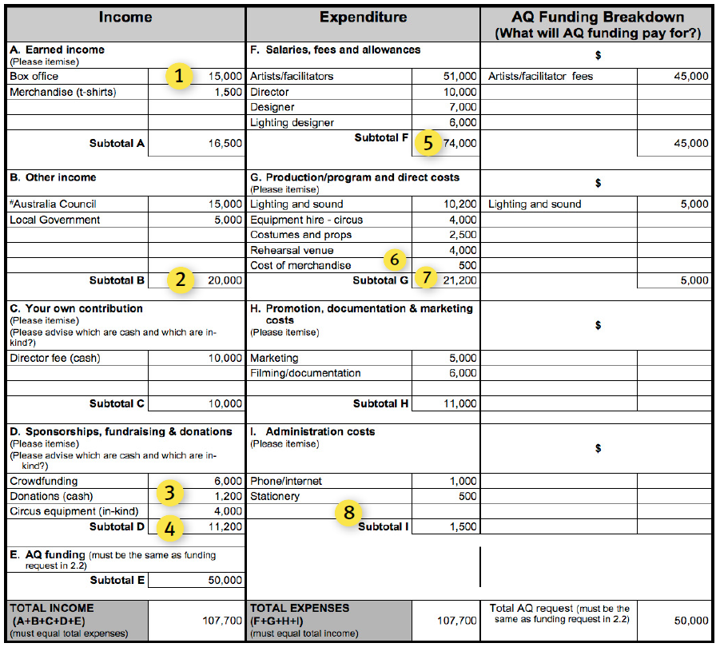
Please note that this budget is an example only. # indicates funding has been confirmed.

What assessors may observe in this budget:
- Is the box-office overly ambitious with $15,000 projected over 3 performances? Assessors will examine estimates and try to understand your assumptions. For example, assume $6,000 in Brisbane and $4,500 in each regional centre. With an estimated ticket price of $15 (to be affordable for a youth market), you would need a full paying audience of 300 in each regional community and 400 in Brisbane. Is this realistic with only one performance in each location? Justify your estimates with evidence of demand.
- It is helpful to know what funding programs you have applied to and date of outcome. Confirmation date for Local Government and Australia Council funding should be provided in application
- It is good to see some diversification of income through merchandising (see earned income Item 1), donations, crowdfunding and an in-kind contribution towards equipment hire. This type of project could be attractive to philanthropic organisations – the application would be strengthened if there was funding from this sector.
- If, as the application asserts, important venue partnerships have been established, why is there no financial contribution – cash or in-kind? (e.g. rehearsal space, discounted technician costs, promotional support etc.). Investment from your partners provides evidence of their commitment and strengthens your application.
- In salaries, fees & allowances, no-one has been identified to manage or administer the project.
- Good to see “cost of merchandise”, this is sometimes overlooked.
- For a project with 3 locations, no travel costs have been included.
- For a project with an element of risk, no insurance has been included.

Example budget: regional gallery exhibition project – Botanica

Context:

- This 8 week exhibition is a collection of historical and contemporary illustrations of plants and flowers.
- It features works by local, national and international artists.
- Some important historical works will be on loan from galleries and libraries across Australia and internationally. This is a major coup for a regional gallery and will be an important component of their marketing campaign.
- The project has a strong community engagement strategy through public art classes and talks led by participating artists, as well as a comprehensive education program.

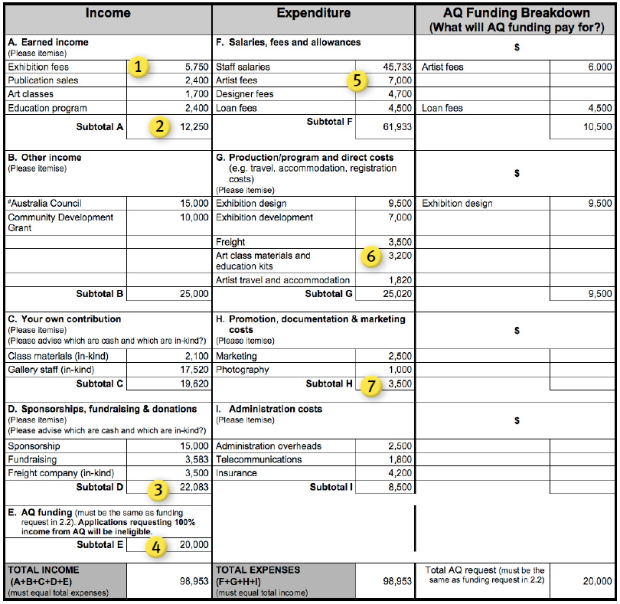
Please note that this budget is an example only. # indicates funding has been confirmed.

What assessors may observe in this budget:
- Given the location of the exhibition is in a mid-size regional centre, earned income levels are modest but realistic.
- The project is well supported through a good mix of income, including own (in-kind) contribution, other government funding, sponsorship (cash and in-kind) and earned fees.
- The project is well planned with evidence of cash and in-kind sponsorship (confirmation letters attached to application).
- Funding requested is modest at approximately 20% of total project costs.
- Artist fees and exhibition development costs are adequate for an exhibition of this scale.
- Offering public art classes, talks and education kits demonstrates sound community/audience engagement strategies which add value to all stakeholders’ investments in the exhibition.
- The marketing budget allocated to this exhibition does not reflect the scale of the project. Insufficient funds (less than 4% of project costs) have been allocated to cover promotion of the exhibition and other community engagement initiatives. With limited time for the public to engage with your project, a strategic and well-resourced marketing strategy will improve your chances of a successful outcome and show your partners you have the skills and capacity to deliver successful projects.

Example budget: career transition opportunity

Context:

- Dan has trained in circus since he was at school.
- He has performed professionally with various circus groups in Qld and in other states for the past 10 years.
- Dan now lives in a regional centre and is working with a youth circus group - Springboard, teaching and performing.
- The group has been invited to perform at a youth arts festival in Ireland.
- The group’s director has asked Dan to tour with them as a performer and mentor for the young performers.
- Dan sees this as a great opportunity to meet with other directors and teachers of young peoples’ performance groups which will assist in transitioning his career from performer to mentor/director.

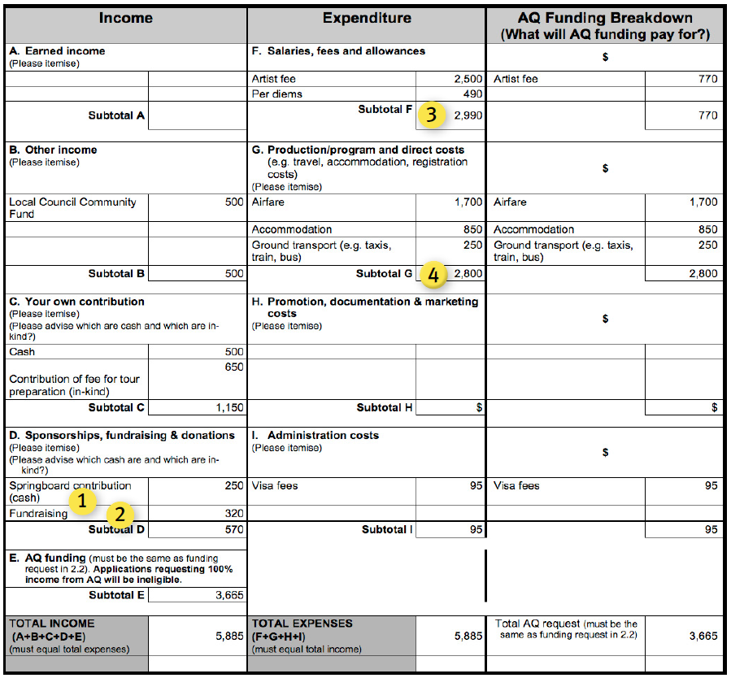
Please note that this budget is an example only. # indicates funding has been confirmed.

What assessors may observe in this budget:
- While it is acknowledged that youth performance groups are often not well funded, Springboard’s contribution to Dan’s engagement would seem inadequate. Dan’s own contribution is greater than the organisation engaging him.
- Good to see efforts have been made with fundraising and with support from local government; many local council’s offer community funding towards various outcomes.
- Dan’s fee and per diems reflect appropriate award rates for his 10-day engagement with the company.
- Ideally the company engaging Dan should cover all fees, travel and accommodation costs, however it is acknowledged that this is not a professional or well-funded organisation and this opportunity is providing Dan with an important career transitioning experience therefore inclusion of an artist fee could be considered appropriate.

Example budget: international residency

Context:
- Kate graduated in 2010 with a Bachelor of Fine Art (Hons) from Qld College of Art.
- She works with soft/fabric based sculptures and has had several solo exhibitions in galleries in Qld and NSW.
- Kate has also been commissioned by a dance company to make sculptural pieces for sets.
- She is keen to diversify her practice and explore wider market opportunities for her work.
- She has been accepted into the Museum of Art of Design, NY, Artist Studio program. The Artist Studio supports the development of original works and fosters dialogue between artists, designers and the public.
- This international opportunity at a prestigious art museum will expose Kate to a broad range of artists and expand her networks within the visual arts, design and performing arts communities.
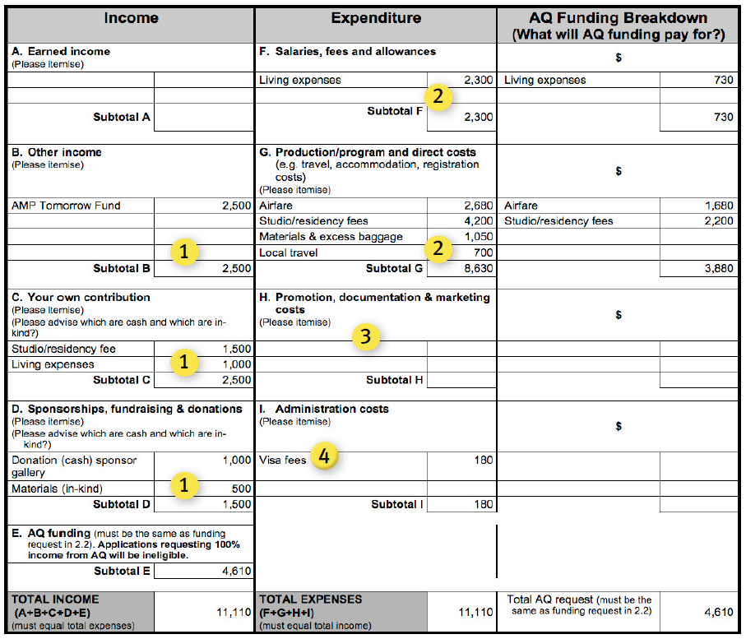
Please note that this budget is an example only. # indicates funding has been confirmed.

What assessors may observe in this budget:
- Through her own contribution, funding from the AMP Tomorrow Fund and modest cash and in-kind sponsorships, Kate is contributing approximately 59% of project costs which would be viewed favourably.
- Kate’s budget estimates for fees & allowances and direct costs appear to be sound (New York is expensive and exchange rates need to be allowed for).
- For a project of this nature and scale, Kate should factor in documentation costs – for her own personal portfolio and records as well as supporting her reporting requirements for her sponsors and funding body. Documentation can include: online profile development, video recording etc.
- Good to factor in all direct costs of international projects. These expenses are sometimes overlooked.

Example budget: mentoring and skill development opportunity

Context:
- Cairns-based Ben has been working as a musician for three years. He has identified an internationally renowned Sydney-based singer-songwriter who has agreed to mentor him in various aspects of songwriting, recording and networking within the music industry and making key introductions to music industry professionals.
- Ben has scheduled three sessions with his mentor in various locations across the east coast of Australia over a six month period. One of these sessions is planned at 301 Studios in Sydney.
- Ben plans to attend the annual Bigsound conference with his mentor to network and further develop his contact base within the music industry. The third mentoring session will be held while both Ben and his mentor are in Brisbane.
- The mentor has offered to provide accommodation for Ben on his second two-day trip to Sydney.
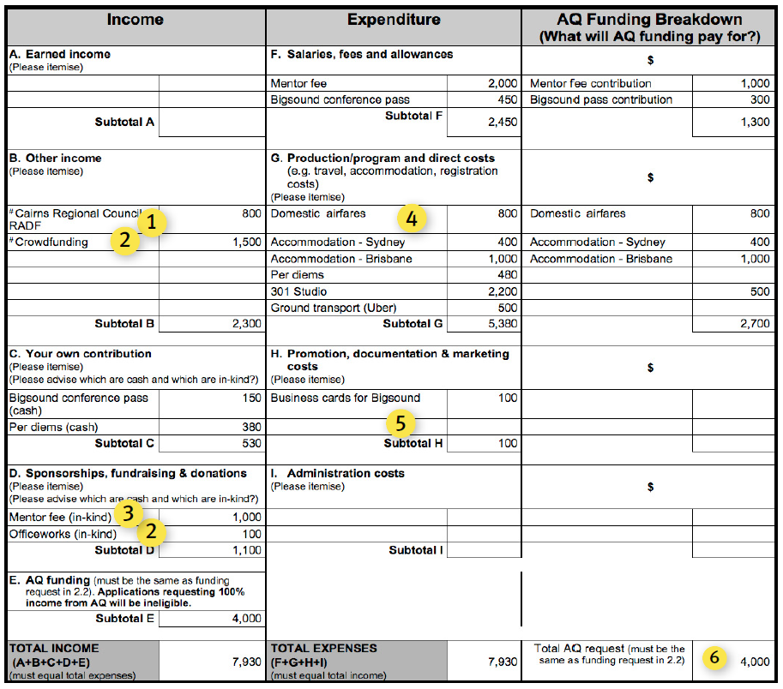
Please note that this budget is an example only. # indicates funding has been confirmed.

What assessors may observe in this budget:
- It is important to consider other funding sources when applying for a grant. Outline in the budget the grant programs you have applied to and if the funding is confirmed. Assessors will consider this favourably as external investment in your project supports its sustainability and shows that others see the value in contributing to your career development.
- Assessors will value the applicant’s success in raising funds from a variety of sources including crowdfunding and in-kind printing costs. It demonstrates there is an audience and community support for the artist/project and that you are organised and committed to the success of the professional development opportunity.
- The mentor is providing half his fee in-kind. Investment from your partners evidences their commitment to your career development and strengthens the application.
- Assessors consider if appropriate budgeting for airfares, accommodation, ground transport and per day allowances has been allocated. In this budget, the airfare allowance for three return flights from Cairns would not be adequate.
- Budgeting for additional promotional material for Bigsound could have been included.
- The budget requests 50% of the overall project costs. This would be considered a reasonable request. Individuals fund will not support 100% of project costs.

